MATLAB Audio Database Toolbox
User Manual

Version 1.00, July 2008

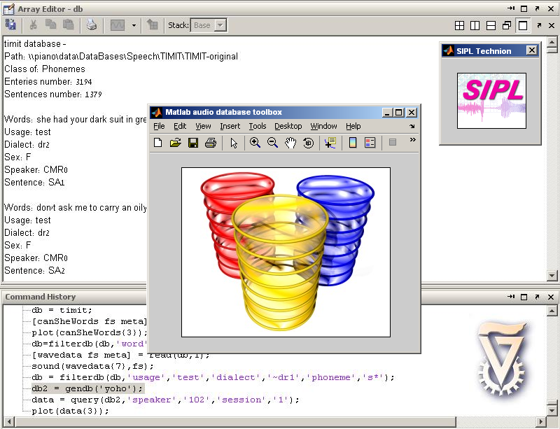


Matlab ADT was developed at the Signal and Image Processing Lab (SIPL), Department of Electrical Engineering, Technion IIT.

Table of Contents

Introduction 3
Quick Start 4
Function Overview 5
Function Reference Guide 6
Usage Examples 9
Appendix - TIMIT/NTIMIT Fields 10

Introduction
MATLAB ADT (Audio Database Toolbox) enables easy access and filtering of audio databases such as TIMIT and YOHO by their metadata. The database toolbox comes to replace the manual filtering and custom coding usually required for accessing such databases. This toolbox will save you the learning time of the database structure and will enable you to focus on algorithmic aspects of your code.

The following databases are supported:
- TIMIT - Acoustic Phonetic Continuous Speech Corpus (American-English). Supported search criteria: word, phoneme, usage, sex, dialect, speaker and sentence. For more information on TIMIT see the appendix at the end of this document.
- NTIMIT - Telephone Network Acoustic Phonetic Continuous Speech Corpus. Supported search criteria: word, phoneme, usage, sex, dialect, speaker and sentence. For more information on NTIMIT see the appendix at the end of this document.
- CTIMIT - Cellular Telephone Acoustic Phonetic Continuous Speech Corpus.
- YOHO - Speaker Verification Corpus. Supported search criteria: usage, speaker, session, numbers.
- TI-Digits - Speaker-Independent recognition of connected digit sequences. Supported search criteria: usage, group, type, speaker and digit.
- Children Voices - Hebrew Speech.
- Hebrew BGU - Hebrew word samples were.
- Gutenberg Books - MP3 format books.

For more information on database structures see the database documentation available on the SIPL site.

For any problem in using Matlab ADT please contact: matlab_adt@sipl.technion.ac.il

Quick Start
Installation at outside of SIPL:
- Extract the files and add "MatlabADT" directory to your MATLAB path
- In Matlab run db = ADT('timit','C:\timit_path_on_your_computer','setup');
This will load timit and set the default path to the directory entered.
For ntimit or ctimit run corresponding commands.
- In case you want to use other databases: in MatlabADT\@gendb\instance directory enter the sub directories and change defalt_path.txt to the directory of the specific database on your computer.
Installation at SIPL workstations:
- Add the "sipl_matlab_utils" directory to the MATLAB path by executing the command: addpath('\\piano\Data\sipl_matlab_utils'); or by using MATLAB menus.
- Run the command timitdemo(); to check installation.
Usage:
- Load the desired database
Loading the database object:
Database name | Loading command
TIMIT | db = ADT('timit');
NTIMIT | db = ADT('ntimit');
CTIMIT | db = ADT('ctimit');
YOHO | db = gendb('yoho');
Ti-Digits | db = gendb('tidigits');
Children Voices | db = gendb(' children voices');
Hebrew BGU | db = gendb(' hebrew bgu');
Gutenberg Books | db = gendb(' gutenberg books');

All operations on the database will be performed using the database object which is passed to them as the first parameter.
- Make a query for your wanted data
[wavdata] = query(db,'dialect','dr1','word',{'she','it'},30);
This call to the query function will return the wave data of the first 30 words 'she' or 'it' form dialect 'dr1' in the form of a cell array

- Accessing the wave data
oneWord = wavdata{1};

Function Overview

Function name | Description
ADT/gendb | Creates database object
query | Returns file data form database by filtering criteria
filterdb | Creates a subset of the database by filtering criteria
read | Returns file data form database
play  getpath  length | Plays a database entire  Returns the path of a specific entire  Returns the number of entries in the object

Function Reference Guide
Note the following usage examples are using the TIMIT database.

query
Usage | [wave fs metadata] = query(db, [criterion1, value1, [criterion2,value2,…]],[max_returns]);
Arguments | Criteria list describing the query
Return value | wave cell array of waveforms  metadata structure array describing waveforms  fs sampling frequency

Remarks
This function queries the database for entries matching the "criterion – value" pairs. Criteria are the fields of the metadata defined by database structure. Following is a short description of these fields. It is optional to pass maximum amount of returned entries.
value parameter may be one of the following:
- criterion content: the query will return only entries matching this value
Example:
query(db, 'sentence', 'SA1')
returns all instances of sentence 'SA1'.
- criterion content negation: if criterion value is preceded by ~ (tilde) then the query will return only those entries that does not match the specified value:
Example:
query (db, 'dialect', '~dr2')
returns all sentences of dialect region other than dr2.
- Cell array of criteria content or criteria content negation: the query will return entries matching either one of criteria.

Example:
wav = query(db, 'phoneme', {'d', 'p'});
returns all instances of phonemes 'd' or 'p'

- criterion content *: either one of criteria.
Example:
wav = query(db, 'word', ‘sh*’);
returns all instances of words starting with sh

filterdb
Usage | filtered_db = filterdb(db, [criterion1, value1, [criterion2, value2,…]], max_returns);
Arguments | Criteria list describing the query
Return value | Subset of timit database passed as an argument

Remarks
Unlike query function, filterdb does not load all waveforms to memory but returns filtered database object. This is useful when the resulting set of the query is too big to fit in memory. Consequent calls to read function can be made to read content of this filtered database object.
See Remarks section of query function for the description of criteria arguments.

read
Usage | [wave fs metadata] = read(db[, index]);
Arguments | timit database object and (optionally) index of the entry to be returned
Return value | wave cell array of waveforms  metadata structure array describing waveforms  fs sampling frequency

Remarks
Returns index entry in the database. If index argument is not specified, returns all entries from the database object passed as an argument.

play
Usage | play(db,index);
Arguments | database object, and index of the entire to play
Return value | null

getpath
Usage | path = getpath(db,index);
Arguments | database object, and index to an entire
Return value | The path to the file containing the entire

length
Usage | n = length(db);
Arguments | database object
Return value | Number of entries in the database

Usage Examples

Example 1

%TIMITDEMO - a timit database interface demonstration,
%Reads text by searching TIMIT database for the words.

db =ADT('timit'); %loads TIMIT database interface
db = filterdb(db,'sex','m'); %filters database for male speakers
text = 'have a good time using this program and enjoy yourself i hope this program is useful';
volume = 1; %assigning the volume
text =strread(text,'%s');%converting Text form string to cell array
for ii=1:length(text)
[word smpr] = query(db,'word',text{ii},1);%querying for the ii word returnig the first match
if ~isempty(word)
max_v = max(word{1}); %normalizing the volume
word{1}=word{1}.*(volume/max_v); %normalizing the volume
sound(word{1},smpr);%play word (words return form query in the form of cell array
pause(0.2); %pauses for 0.2s
end
end

Example 2

%GENDBDEMO a demonstration of gendb
%loading YOHO database
db = gendb('yoho');
%filtering YOHO database returning 3 first eateries matching the query
db = filterdb(db,'usage','verify','speaker','10*',3);
%loading Hebrew BGU database
db2 = gendb('Hebrew BGU');
%selecting a random index
index = fix(rand(1)*length(db2))+1;
%playing index entire
play(db2,index);
%reading wave data from filtered YOHO database
wavedata = read(db);
%plotting entire number 2
plot(wavedata{2});

Appendix - TIMIT/NTIMIT Fields

Filed | Content | Description
Usage | train, test | Train/test set defined by TIMIT
dialect | dr1, dr2, dr3, dr4, dr5, dr6, dr7, dr8 | Dialect regions as defined in TIMIT documentation
Sex | m,f | Gender of the speaker
speaker | Four alphanumeric characters | The id of the speaker as given by TIMIT
sentence | Up to 5 characters. Format defined in TIMIT documentation | Sentence id as defined by TIMIT
word | Word | Any word from a sentence present in TIMIT
phoneme | Phoneme | Any phoneme from a word present in TIMIT. Phoneme codes can be found in TIMIT documentation

The TIMIT/NTIMIT database eateries can take the form of sentences words or phonemes.
The query or read functions will return a cell array, The returned cell array of waveforms will contain waveforms of entire sentences, words or phonemes, depends whether the query result is sentence, word or phoneme. The query result is determined by the "finest" query term in a query.

Query example | Finest term in a query | Content of each cell in a returned cell array
query(db, 'sentence', 'SA1', 'dialect', 'dr1', 'sex', 'm') | 'sentence', 'dialect', 'sex' | Sentence
query(db, 'sentence', 'SA1', 'dialect', 'dr1', 'sex', 'm', 'word', 'she') | 'word' | Word
query(db, 'sentence', 'SA1', 'dialect', 'dr1', 'sex', 'm', 'phoneme', 's') | 'phoneme' | Phoneme
query(db, 'sentence', 'SA1', 'dialect', 'dr1', 'sex', 'm', 'word', '#all') | 'word' | Word
query(db, 'sentence', 'SA1', 'dialect', 'dr1', 'sex', 'm', 'phoneme', '#all') | 'phoneme' | Phoneme
Special value '#all' can be used to force finest term in a query without actually filtering by that criterion. For example query(db, 'sentence', 'SA1', 'dialect', 'dr1', 'sex', 'm', 'phoneme', '#all') will return all phonemes in the requested sentence.

